RTOS Project Week 6 Summary

This week, I completed all of the tasks except for the last right LED. I also made some modifications to my original program so that it can have more functional tests. These changes might make the game seem reasonable once someone plays it.

The first task that I made change of was the platform task. Instead of just detecting the left or right direction of the slider, I split the direction into 4 parts: left most, slightly left, slightly right, right most. If I press the left most and the rightmost button of the slider, it will apply the max force to the platform, whereas for slightly left and right buttons, I only apply half of the force.

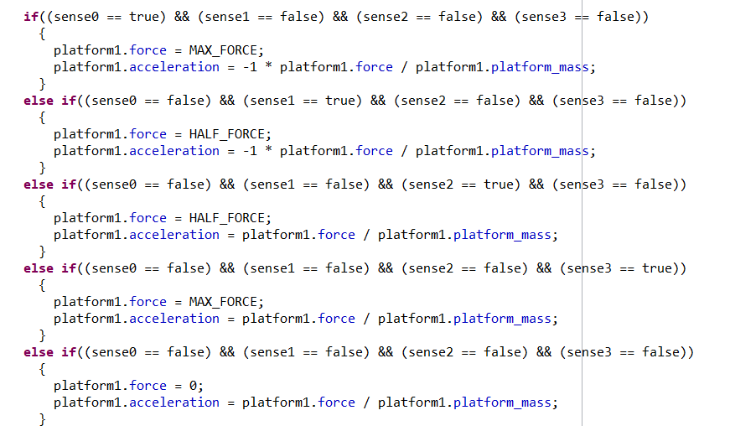

The amount of force I apply to the platform corresponds to the turn on time of the left LED. If the amount of the force applied to the platform is max force, the left LED should be turned on at all times. If there is only half of the force applied to the platform, the left LED should turn on for a period of time and turn off for the same period of time.

Second things I added to the program are the number of balls there will be and the number of chances to destroy the ball. In my button1 irq handler, I only set 1 chance of the laser option so that it will not be used as a convenient way to win the game. In addition to that, I gave the option to have multiple balls so that every time we shoot the ball to the ceiling, the ball will be destroyed and the next ball comes.

Right now I’m almost done with the final project except for one of the LED tasks. I can probably get it done next week before the demo. Although there were lots of challenges, the project is still very fun.